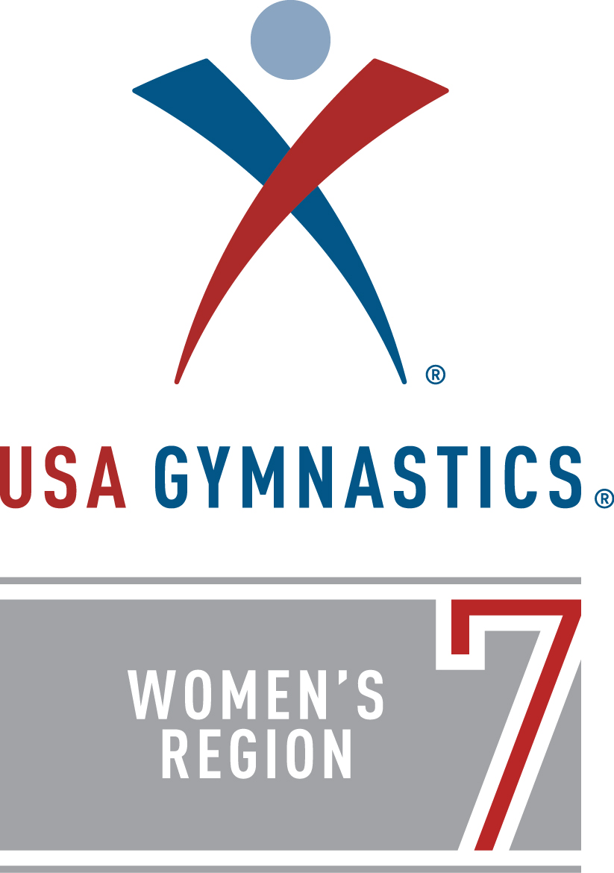

Level 8 Regional Championships

April 6-8, 2018
Boo Williams Sportsplex, Hampton VA
Hosted by World Class Gymnastics
2018 Region 7
Level 8 Regional Championships
Meet Information

Dates: April 6-8, 2018
The final schedule will be out as soon as get all Regional Qualifier entries.

Host Club: World Class Gymnastics
343 Bell King Rd, Newport News, VA 23606
757-881-9920 gym 757-881-9923 fax
Email: Gymsme2@aol.com
www.worldclassgym.com

For updates: Go to www.region7usagym.com or www.worldclassgym.com.

Meet Director: Debbie Le Moal, email at gymsme2@aol.com

Venue: Boo Williams Sportsplex, 5 Armistead Pointe Parkway, Hampton VA 23666
http://www.boowilliamssportsplex.com/ Directions under Plan Your Visit.

General Info: All Level 8 athletes that score a 35.00 AA or higher at their State meet will qualify to the Level 8 Regional Meet. No petitions to Level 8 Regionals. No IES at Level 8 Regionals.

Entry Fee: All registration must be made through www.meetmaker.com. Entry fee is $115. Online payments required at the time of registration. Please note that there is a 3% charge for credit card transactions. No additional fee for payments made via ACH from checking account. Registration will open from the start of the first session of the State Meet and will close at midnight on the Monday after the State meet. A $50/gymnast late fee will be added through MeetMaker if registration received after the deadline. No refunds after March 26, 2018.

The entry process is a multiple step process for completion. Entry is not complete until you pay and get a confirmation number from MeetMaker. Complete instructions are at the end of this packet and at http://www.region7usagym.com/.

New in 2018: The best of each State will compete in the Premier session Saturday night to earn bragging rights to the title Level 8: Best State in Region 7. Each state will field a team comprised of the TOP 8 GYMNASTS based on State Championships All-Around scores, regardless of age group. The best of the best will compete against each other in a special session. More details will be announced in March. Please check www.region7usagym.com.

Age Groups: Age groups will be determined by the total athletes qualified and will be distributed as quickly as possible after the last State Meet.

Gifts: Region 7 will provide a tank leotard for all competitors. Region 7 will also provide a Regional T-shirt to all competitors and coaches.

Awards: Awards for the top 25% in each age division.
Coaches: Coaches must present current USAGym Professional Membership credentials at check in. There will be a Coaches Meeting at the beginning of each session. Hospitality will be provided.

Meet Format: Modified Capital Cup

Equipment: Vault Board: AAI TAC/10 Vault Board
Vault Tables: AAI TAC/10 Vault Table
Bars: AAI Elite Uneven Bars and Graphite E (soft) rails
Beam: AAI Elite RA Balance Beam, 12cm base mat
Floors: identical AAI Artistic Floor Exercise System, one with carpet and foam and one with carpet bonded foam.
Mats: 8” skill cushions, 4” supplemental throw mats and sting mats available at every event.

Floor Music: All coaches MUST provide Floor Exercise music in digital format (MP3, computer, tablet, smart phone etc.). All electronic devices must have a display screen and must be on airplane mode, when applicable. ALL FLOOR MUSIC MUST BE IN DIGITAL FORMAT. CD playback equipment will not be provided.

Trainer: An onsite trainer will be available for all coaches and gymnasts during warm-ups and competition.

Gate Fees: $10/day Ages 15 and up
$8/day Senior Citizens
$5/day Ages 6-14
Free Ages 5 and under
Gymnasts competing at Level 8 Regionals are not charged for any session.

Graduating Seniors: Senior forms due no later than Friday, March 23. We are planning to make special for the Seniors, so we need all turned in on time. Form in this packet or online at www.worldclassgym.com. In addition, we would like all graduating seniors to send in a head shot picture so we can include in the program at no cost. Please see SENIOR BIOGRAPHY and PROGRAM AD INFO in this packet.

Program Ads: See information in this packet or at www.worldclassgym.com. Ads must be submitted and paid in full by Friday, March 23.

Airports: Newport News/Williamsburg International PHF (15 mins from venue)
Norfolk International ORF (20 mins from venue)

Host Hotels: In Coliseum Central area

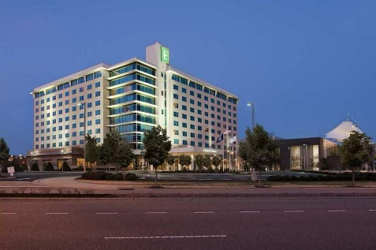 EMBASSY SUITES, 1700 Coliseum Dr., Hampton, VA 23666. (757) 827-8200. $129 per suite, per night plus taxes. Cut off 3/19/2018.
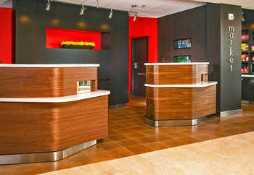 COURTYARD MARRIOTT, 1917 Coliseum Dr., Hampton, VA 2366-4235. (800) 321-2211. $119 per night plus tax, 2 Queen. Cut off 3/22/18.

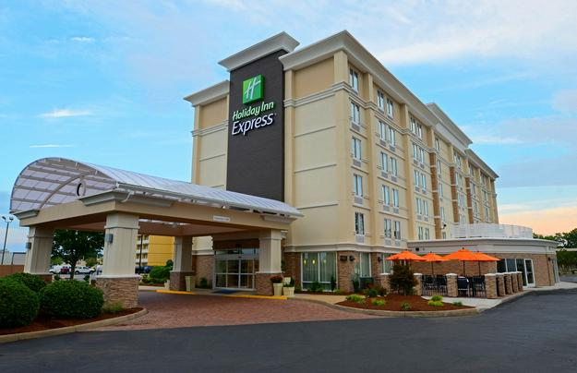 HOLIDAY INN EXPRESS, 1813 West Mercury Blvd, Hampton, VA 23666 (757) 838-8484. $129 per night plus tax, King Sofa bed or 2 Double. Cut off 3/18/18.

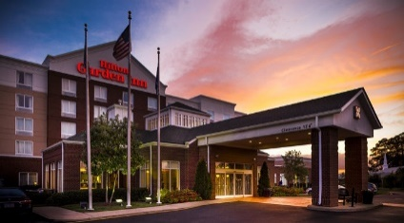 HILTON GARDEN INN, 1999 Power Plant Parkway, Hampton, VA 23666. (757) 310-6323. $129 per night plus tax, 2 Queen. Cut off 3/7/18.

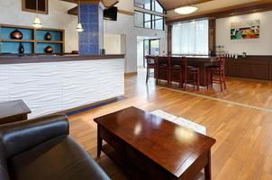 BEST WESTERN HAMPTON COLISEUM INN, 1916 Coliseum Dr., Hampton, VA 23666. (757)827-5052. $89.99-$109.00 per night plus tax for 2 Queens; $79.99-$99.99 for 1 King. Cut off 3/5/18.

2018 Region 7 Level 8 Championship
Graduating Senior Biography
Please complete and fax to 757-881-9923 or email to gymsme2@aol.com no later than March 23. We are making something for the seniors, so we need to get this info in on time. Don’t forget to look at the Program Ad page about sending in your head shot for the program.

Please write legibly. Don’t exceed the space given. Deadline – March 23, 2018.

SENIOR’S INFORMATION

Name: _________________________________________
Level: ___________Phone: ___________________________

Team: ______________________________________________

Future Plans: (such as college, scholarships, etc.) ___________________________________________________.
One short sentence comment from the senior, think Instagram Caption: ____________________________________________________ _________________________.

COACHES’ INFORMATION

Name: _____________________________________________________________

Name: ____________________________________________________________
Give two words that describe your gymnast. (Two words ONLY because we are going to make something for each senior and we can only use two words. ) Examples are “determined, talented,” “floor diva,” “most dedicated.”

______________________ _______________________

If emailing, please save the file using the gymnast’s name and email to gymsme2@aol.com or fax to (757) 881-9923.

2018 Region 7 Level 8 Championship
Program Information for Graduating Seniors and Good Luck Ads

Graduation Seniors: Please email a head shot so that we can include you in the senior section of the program. Email to worldclassprograms@outlook.com. In the subject line write, SENIOR and your name. In the body of the email, write (1.) your name, (2.) your team, (3.) your high school name and (4.) name of college you will be attending if you know already. Please read the rest of the form for general information about pictures. No charge to be included in the Senior Section. Deadline March 23, 2018.

Good Luck Ads: Reserve your 2018 Region 7 Level 8 Championship Good Luck Advertisement! All ads must be submitted and paid in full by March 30, 2018. Ads received after that date may not make the cutoff to the printer.

Contact Name: ________________

Telephone: _

Email Address: _________________

Gymnast's Name: _________________

Gymnast's Club: _________________

Ad Size
_______Full page (approx. 8.5x5.5 vertical) $100 $__________
__________Half page (approx. 5.5x4.25 horizontal) $75 $__________
__________Quarter page (approx. 2.75x1.88 vertical) $50 $__________

__________Make it a color ad for only $25 more! $25 $__________

STEP 1: Mail this form and payment to
Program Ad: Region 7 Level 8 Championship
WCGPA
343 Bell King Rd, Newport News, VA 23606

STEP 2: email completed and ready to go ad to worldclassprograms@outlook.com. Put your gymnast’s name in the Subject line and a copy of this form in the email so we can correctly identify you.

Pictures must be at least 300dpi. Provide final ads in these formats: pdf, Microsoft Word, PowerPoint or Publisher. When creating your ad, keep in mind the size of the ad you are purchasing. The quality picture supplied will determine the clarity in the program. If you selected a black and white ad, but sure there is enough contrast in the picture so the gymnast doesn’t “disappear” into the background.

Restaurants and Activities

Restaurants, Shopping and Movies:
The Boo Williams Sportsplex is located in Coliseum Central area and near Peninsula Town Center, a premier new-style shopping center with shops, restaurants, and a movie theater. www.peninsulatowncenter.com In Coliseum Central there are plenty of malls, restaurants and activities. To see shops and activities in Hampton, go to www.visithampton.com.

Williamsburg and surrounding areas have tons of shopping and quality outlet malls. People travel from far and wide to shop in Williamsburg. www.visitwilliamsburg.com Williamsburg is an easy 20 to 30 minute drive. Go West on I64 and follow the signs.

Norfolk, about a 35 minute drive going on I64 East, one of the biggest malls in the area. MacArthur Center is a great way for a shopper to spend the day. /www.shopmacarthur.com/

Activities:
Yorktown and Jamestown are both historic and fun. Yorktown is about 15 minutes and Jamestown is about 35 minutes away. For more information, go to www.historyisfun.org.

Colonial Williamsburg is both a place of history and shops and restaurants, and about 30 minutes away. To learn more about the historical part, go to www.history.org. For shops and restaurants within Colonial Williamsburg and across from the College of William and Mary, go to www.merchantsquare.org.

Virginia Beach is fun anytime of year. It is about 45 minutes to the resort/board walk area. For more information, go to www.vbfun.com .

Busch Gardens Williamsburg is OPEN the week of Regionals! Busch Gardens is about 20 minutes away. For more info go to www.seaworldparks.com and click on Busch Gardens Williamsburg.

Come for the CHAMPIONSHIPS, but have a little fun in our area too!

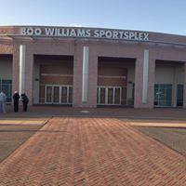

Directions & Parking: Boo Williams Sportsplex
Boo Williams Sportsplex is located at the intersection of Armistead Ave and Hampton Roads Center Parkway . 5 Armistead Pointe Parkway, Hampton, VA 23666. http://www.boowilliamssportsplex.com/ look under Plan Your Visit

For people traveling from Williamsburg and Points North
- Take I-64E
- Take exit 261B for Hampton Roads Center Parkway E
- Merge onto Hampton Roads Center Parkway and cross Armistead Avenue to enter the Boo Williams Sportsplex parking lot.
For people traveling from Suffolk, Chesapeake
- Take I-664 North toward Newport News
- Merge onto I-64 West via exit 1A on the Left toward Williamsburg/Richmond
- Merge onto VA-134 N/MAGRUDER BLVD. via exit 262B toward NASA/Poquoson
- Turn Right on Hardy Cash Drive
- Turn Left on Coliseum Drive
- Merge Right onto Hampton Roads Center Parkway and cross Armistead Avenue to enter the Boo Williams Sportsplex parking lot.
For people traveling from Norfolk, VA BEACH
- Begin on I-64 West toward Hampton/Richmond
- Merge onto VA-134 North/MAGRUDER BLVD via exit 262B toward NASA/Poquoson
- Turn Right onto Hardy Cash Dr.
- Turn Left onto Coliseum Drive
- Merge Right onto Hampton Roads Center Parkway and cross Armistead Avenue to enter the Boo Williams Sportsplex parking lot.

2018 Region 7 Level 8 Championship
ENTRY INSTRUCTIONS for MeetMaker
For DE, MD, NJ, PA, WV. (VA will be entering through State Chairman.)

For the Region 7 regional meets in the 2017-18 season, all regional registrations on MeetMaker will go through the USA Gymnastics Reservation system then complete registration and make payment on MeetMaker. You do not need to update your MeetMaker roster, the reservation will update it for you.

To make sure the reservation will be linked to your gym account in MeetMaker make sure you have your USA Gymnastics Club Number in your MeetMaker account profile (reservations are linked by club number)
- Sign in to MeetMaker click MY GYM then Click MY ACCOUNT
- Click SANCTION ORGANIZATIONS
- Your USA Gymnastics Cub Number should be in this grid
- If not click ADD NEW, or if it is wrong click EDIT to make sure your club number is listed correctly.
- If you happen to have more than one USA Gymnastics entry DELETE any extra entries.

For a regular entry:
- Find the meet you are entering click REGISTER
- Click the button, “USA Gymnastics Reservation System” click this button
  - A new tab or window will open (depending on your browser) with USAGYM.ORG sign in web page [Sign in to your USA Gymnastics account]
- Once you sign in you will see the reservation page for the meet you are entering
- Fill in the reservation data and select all the coaches and gymnasts that are going to attend the regional meet and complete the reservation
- Go back to the MeetMaker window and click ALERTS
- Then Process this reservation and enter payment information [you will receive a confirmation number in MeetMaker]
For help please see the instruction page: http://www.meetmaker.com/usagreservationinfo or contact support@meetmaker.com

To EDIT a registration for the regional meet:

TO UPDATE YOUR CURRENT MEET REGISTRATIONS IN MEETMAKER FOR A MEET THAT USES THE USA GYMNASTICS RESERVATION SYSTEM:

Scratch A Gymnast If the meet is in regular or late registration (if the cancelation date in the sanction has passed you can not scratch)

- Click “MY GYM” then “MY MEETS”
- Click “ADD NEW REGISTRATION” in the line of the meet you need to edit the registration
- Click the “USA GYMNASTICS RESERVATION SYSTEM” button
- Login to USA Gymnastics
- Cancel the gymnast in the reservation and complete the reservation
- In the MeetMaker window click “ALERTS”
- Process the new reservation for that competition
- You will be notified that the gymnast is scratched

Change General Info in a Gymnast Registration (Clothing Size, Notes and Team Member Status)
- Click “MY GYM” then “MY MEETS”
- Click “VIEW REGISTRATIONS” in the line of the meet you need to edit the registration
- Click the “VIEW” button for the CONFIRMATION you need to edit
- To edit the additional registration information for a Gymnast, click the “EDIT” button (not the down arrow)
- Edit the information needed the click “SAVE”
- Click “SAVE UPDATES” Above the Confirmation Bars.

